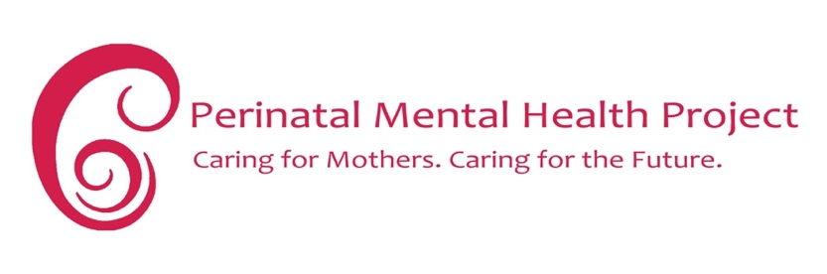
PMHP 4-question maternal distress screening tool
Hello. My name is ………. and I’m a …(type of care provider) at …(name of facility/service). Here, we’d like know how our clients are feeling because we know that pregnancy can be a time of stress for some women and girls. So we’re asking all our clients to answer some questions about how you are feeling and about things that have happened in your life. Will you be okay to do this with me?
I’m going to start by asking you 4 questions. Please answer ‘yes’ or ‘no’ to each question.

In the last 4 weeks, have you often (on some or on most days)

 | Questions | YES | NO
1 | Felt unable to stop worrying, or thinking too much?
2 | Felt down, depressed or hopeless?
3 | Felt little interest or pleasure in doing things that you used to enjoy before?
4 | Had thoughts and plans to harm yourself or commit suicide?

Action
If yes to Number 4 → refer to mental health nurse/doctor immediately (no matter the other scores)
- If she has any self harm thoughts and plans, urgent referral is required to trauma unit or mental health nurse – same day!

If total 2 or more ‘yes’ answers for questions 1-3→ for counselling
- Explain that this shows she may (not for sure) have a common mental health problem such as depression or anxiety
- that about 1 in 5 women have these problems around pregnancy
- that with the right help, women can and do get better
- ask if she would like to talk to someone about her problems
- if she declines – keep an ‘open door’ policy for her to change her mind when she is ready
- give psychoeducation material whether she accepts referral or not.
- See http://pmhp.za.org/resources/parents-families/ for free materials for download
PMHP- 4 Isixhobo Sokuhlola Uxinzelelo Kumama Okhulelweyo
Molo, igama lam ndingu . ................... ndiyi (uhlobo lomnikezi nkathalo) yase ( igama lendawo yoncedo/nkonzo). Apha singathanda ukwazi ngemizwa yezigulana zethu ngoba siyayiqonda ukuba ukukhulelwa ingaba lixesha elinoxinzelelo kwabanye abafazi. Sibuza zonke izigulane zethu imibuzo embalwa malunga nemizwa nange zinto ezenzeke ebomini. Ingaba kulungile uba singa qhubeka ngemibuzo?
Ndizakuqala ngokubuza imibuzo emine. Ndicela uphendule ‘ewe’ okanye ‘hayi’ kumbuzo ngamnye.
Kwiveki ezine (4 weeks) ezigqithileyo, ubuke wamane (ngezinye emini okanye intsuku ezinintsi).
 | Imibuzo | EWE | HAYI
1 | Ukhe uzive ingathi awukwazi ukuyeka ukucinga okanye ukucinga kakhulu?
2 | Ukhe uzive umoya wakho uphantsi, uphelelwe lithemba okanye uziva udepressed?
3 | Ukhe uzive uphelelwe ngumdla okanye ubumnandi kwizinto ubuqhele uzenza ngaphambili ebezikade zikonwabisa?
4 | Ubukhe ubenazo na ingcinga zokuzibulala nokuzenzakalisa?
Imiyalelo
Ukuba uphendule ewe kumbuzo wesine – mthumele ku gqirha okanye unesi ngoko nangoko (nokuba amanye amanqaku athini)
- Ukuba unazo iingcinga namacebo okuzenzakalisa, mthumele ngoko nangoko kwigumbi lokuxakeka okanye kunesi osebenza ngezigulo zengqondo – kwa ngolo suku !
Ukuba impendulo ngu ewe kwimibuzo 1-3 – mthumele kwi counselling
- Cacisa ukuba oku kubonisa ukuba angaba (hayi ngokuqinisekileyo) unengxaki eqhelekileyo yengulo ngengqondo enjengoxinzelelo lwengqondo okanye inkxalabo.
- Ukuba umfazi omnye ebafazini abahlanu (1 in 5) bathanda ukuba nezinxaki xana bekhulelwe
- Ukuba ngoncedo olufanelekileyo, abafazi bayakwazi ukubangcono
- Mbuze ukuba angathanda ukuthetha nomnye umntu ngenxaki zakhe na
- Ukuba akafuni, mxelele ukuba wamkelekile ukuza naninina xana eziva efuna ukuthetha
- Mnike iincwadi zolwazi nokuba akafuni ukugqithiselwa
- Yiya apha ku http://pmhp.za.org/resources/parents-families/ ukuze ufumane ezinye izixhobo ezinokunceda simahla

